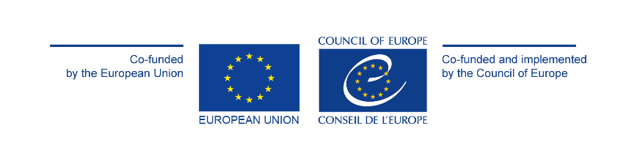

Joint European Union - Council of Europe
Child-friendly Justice Project
Final Conference

27 May 2026
Organised by the Ministry of Justice of the Hellenic Republic
and the Council of Europe

In Athens – Auditorium of the Acropolis Museum
And Online at the following link:
https://www.youtube.com/live/10uksmkS9DU

The project is co-funded by the European Union and co-funded and implemented by the Council of Europe,
in co-operation with the European Commission, Directorate General for Justice and Consumers

Joint Child-friendly Justice Project
The Joint European Union-Council of Europe Child-friendly Justice project is an innovative 30-month initiative driven by the combined efforts of the Council of Europe and the European Commission Directorate-General for Justice and Consumers (DG JUST) and implemented by the Children’s Rights Division of the Council of Europe. Launched on 1 January 2024, the project aims to improve the protection of children in contact with the law – as offenders, victims, witnesses or parties in non-judicial, judicial (such as civil and criminal cases) and administrative proceedings – across Europe at national and local levels.
Belgium, Poland, and Slovenia were selected as focus countries to pilot the implementation of activities at national and local level to collect data, identify gaps, improve legislation, policies, and practices. Greece, Hungary and Portugal joined the project as partner countries to stand in the project steering committee, provide guidance, advise on the activities, share approaches and good practices, and benefit from the achievements of the action.
From July to December 2024, Belgium, Poland, and Slovenia conducted their self-assessment through the roll-out of the Council of Europe Child-friendly Justice Assessment Tool (translated into Dutch, French, Polish and Slovenian, and available in a child-friendly version), operationalising Council of Europe Guidelines on Child-friendly Justice. A roundtable with children in contact with the law was held to present the findings of the self-assessments. The analysed data helped formulate recommendations to adapt the three focus countries’ legal and policy framework, in line with the Council of Europe and European Union legal standards and acquis in the field of child-friendly justice.
Between September and December 2025, capacities of multidisciplinary professionals working for and with children in contact with the law were strengthened with the support of the Course: Child-friendly Justice | Council of Europe HELP (translated into French, Dutch and Slovenian and already available in Polish) and on child participation in judicial and non-judicial proceedings (in the three focus countries), the rights of children in migration context (in Belgium), inter-agency coordination in the field of child-friendly justice (in Poland) and guardians ad litem (in Slovenia).
In October-November 2025, the awareness of children in contact with the law and adults was also raised on the rights of children in judicial and non-judicial proceedings in Belgium, Poland, and Slovenia.
A Handbook on the state of play of child-friendly justice in Europe was also drafted. The Handbook sets out international and European law and standards that have emerged on child-friendly justice, explores good and promising practices and identifies where further reform is still needed.
Finally, a feasibility study on diversion, alternatives to detention, prevention of offending and reoffending and restorative Justice was conducted. The study analyses national practices across Europe and assesses the potential for an annex of the Child-friendly Justice Assessment Tool.
The objective of the final conference in Athens is to showcase the results and deliverables of the Joint Child-friendly Justice Project, discuss the remaining needs and introduce Phase II of the Joint Project.

Programme of the Final Conference
27 May 2026
9:00-9:30 | Registration of participants
9:30-10:20 | Welcoming remarks  - Giorgos Floridis, Minister of Justice of the Hellenic Republic  - Dora Bakoyannis, Vice President of the Parliamentary Assembly of the Council of Europe  - Theodoros Roussopoulos, Former President of the Parliamentary Assembly of the Council of Europe  - Michael McGrath, European Commissioner for Democracy, Justice, the Rule of Law and Consumer Protection – pre-recorded message  - Marja Ruotanen, Director General of Democracy and Human Dignity, Council of Europe  - Eftychia Katsigaraki, General Director of Special Legal Affairs, Ministry of Justice of the Hellenic Republic
10:20-11:00 | Panel Discussion – A deep dive into children’s further needs within justice systems  Led by children from Chania and Piraeus
11:00-11:30 | Coffee break
11:30-11:45 | Keynote speech – Child-friendly Justice in Europe: progress made, current trends and challenges ahead  - Nantina Tsekeri, Director of Defence for Children Greece and Vice-President of the Child-friendly Justice European Network
11:45-12:00 | Presentation of key results and deliverables of the Joint Child-friendly Justice Project  - Anne-Laure Baulieu, Senior Project Officer, Children’s Rights Division, Council of Europe
12:00-12:10 | Presentation of key findings and recommendations of the final evaluation  - Joanna Włodarczyk, Ecorys Poland
12:10-12:20 | Closing Remarks – The way forward during Phase II  - Zaruhi Gasparyan, Head of Cooperation and Capacity Building Unit, Children’s Rights Division, Council of Europe  - Chrisoula Arcoudis, Policy Officer, Rights of the Child, European Commission DG JUST
12:20-12:45 | Dance performance by children
12:45 | Family Photo
12:45-14:00 | Lunch
14:00-16:00 | Optional: tour of the Acropolis Museum

